No plastic or paper packaging

Many companies are switching to paper packaging instead of plastic packaging to become more sustainable, especially with the new Plastic Packaging Tax Regulations. However, switching to paper also has its environmental issues.

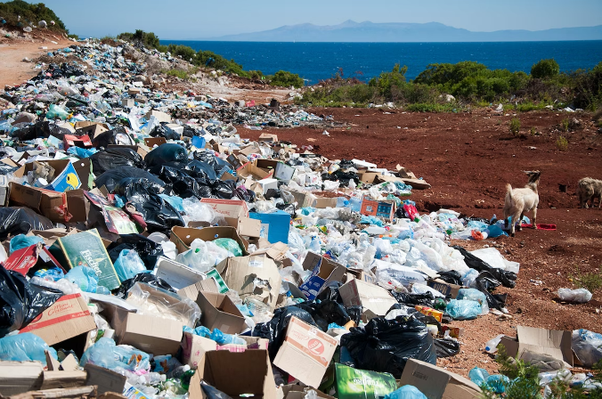For example, cardboard production is water intensive, generates emissions and runs the risk of encouraging deforestation if not sourced sustainably. On top of that, it is difficult to recycle if it is contaminated with food or other waste.

Paper and Cardboard

Both paper and cardboard are seen by many brands as the quick solution to help them achieve their plastic reduction targets. Due to the explosive growth in e-commerce last

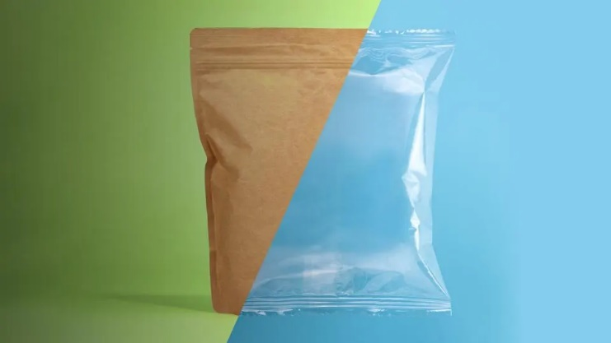year amongst other factors like the pandemic, we are currently experiencing cardboard shortages as the demand for corrugated cardboard has surpassed the capacity of paper mills. It has even been named ‘the hunt for beige gold’.