**Fewer cars on the roads**

Fewer cars on the roads is a goal. Gaseous toxic substances are atmospheric pollutants, of which four main pollutants are distinguished: carbon monoxide (accounting for 52% of total emissions), sulfur oxides (18% of emissions), hydrocarbons (12% of emissions) and nitrogen oxides (6% of emissions). The main sources of these pollutants are transport (60%), industry (18%), electricity generation (13%), heating (16%), waste utilization (3%). Transport is one of the most polluting sectors, so it is necessary to decide how to reduce the volume of its pollution and the damage it causes to the environment and the health of the population.

Use public transport more and other means of transportation that do not use fuel, such as bicycles, tricycles, rollerblades, scooters. Plan your car journeys. Save fuel and reduce air pollution. Turn off the engine when the car is stationary, if you are stuck in traffic or if you are going to be stationary for more than a minute. Drive calmly - sudden braking or speeding increases fuel consumption. L

et's protect nature and the health of all people. Try to drive less with vehicles!

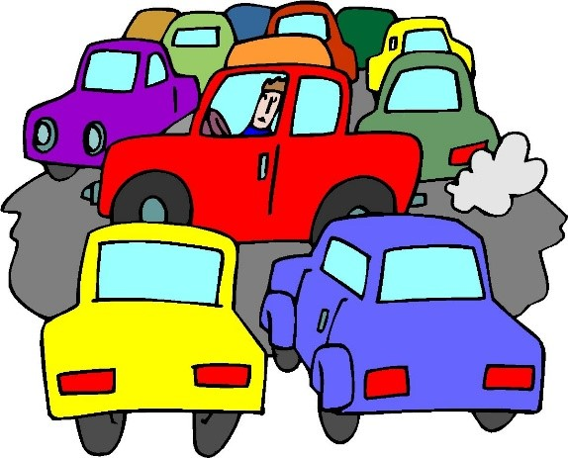**Words-171**