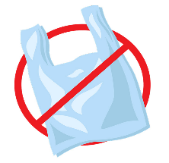 1.REFUSE-Start by refusing what you don’t need, things that will quickly become trash, like a plastic bag at the grocery store or a plastic straw at restaurant.

2.RECYCLE- time to recycle items that can’t be refused, reduced, or resued. Remember to sort and clean your recyclables accoring to the local regulations in your area.

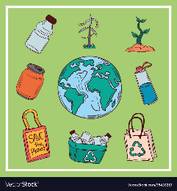

3.REFUSE-After refusing and reducing it’s important to reuse what you can, for example, making salad dreesing with an almost empty mustard jar or repairing your favorite pair of jeans instead of buying something new.